Data Analytics
RMX DA 2 DIS Overall Process
Requirement Document

Template Revisions | Date | Change
V1.0 | 05/08/2009 | Initial Version


© 2009 CSC. Falls Church, Virginia. All rights reserved. No part of this publication may be reproduced by any means without written permission from CSC. Printed in U.S.A. All questions regarding this documentation should be routed through customer assistance, Blythewood, SC, 800-420-6007 or email pcssupport@csc.com.

Table of Contents

1. Requirement Overview 3
1.1. Assumptions and Constraints 3
1.2. Current Scenario 3
1.3. Proposed Scenario 3
1.4. Functions to be addressed 3
2. Requirement 4
2.1. Functional Considerations 4
2.2. Design Considerations 4
2.3. Interface Considerations 4
2.3.1. System Interfaces 4
2.3.2. Hardware Interfaces 5
2.3.3. Software Interfaces 5
2.3.4. User Interfaces 5
2.4. Performance Considerations 5
3. Dependencies between Requirements 5
4. Approach 5
5. Signoff 7
6. References 8
7. Requirement Change Log 9

1. Requirement Overview

RISKMASTER Data Import System (DIS) imports external data to the RISKMASTER database.

Assumptions and Constraints

- RISKMASTER X R6 to be generally released.
- All data will be imported in the “SampleDis32.mdb” format.
- Data Services 3.2 will be used.

Current Scenario

The DIS application is currently written in Visual Basic 6 and is independent from the RISKMASTER application. DIS allows users to select a single data area from a dropdown list to import. The users are required to know the import order of the data areas. Each DIS execution can only run a single data area. If more than 1 Data Area is needed to be run, the user has to setup DIS up again. DIS imports given area, the data of selected area have to be stored the “SampleDis32.mdb” file format. If the data passes all the validations, then DIS imports them into the RISKMASTER database. If the data fails validation then it stores the record in the error log file. Lastly, DIS lets the user view, print and save the database schemas of their supplemental tables.

Proposed Scenario

The new version of DIS will be written Data Services and will integrate into RISKMASTER X R6 Task Manager. It will be a Data Analytics (DA) module. The users will have the ability to schedule a DA DIS job in RMX R6 Task Manager. No change will be made in how the incoming data is validated. New functionality will be added to allow users to view the resulting error logs in Task Manager and correct validation errors.

Functions to be addressed

The key features of this enhancement are as follows:

- DA DIS is integrated into RISKMASTER X R6
- User will be able to schedule DIS
- User will be able select more than one import at a time
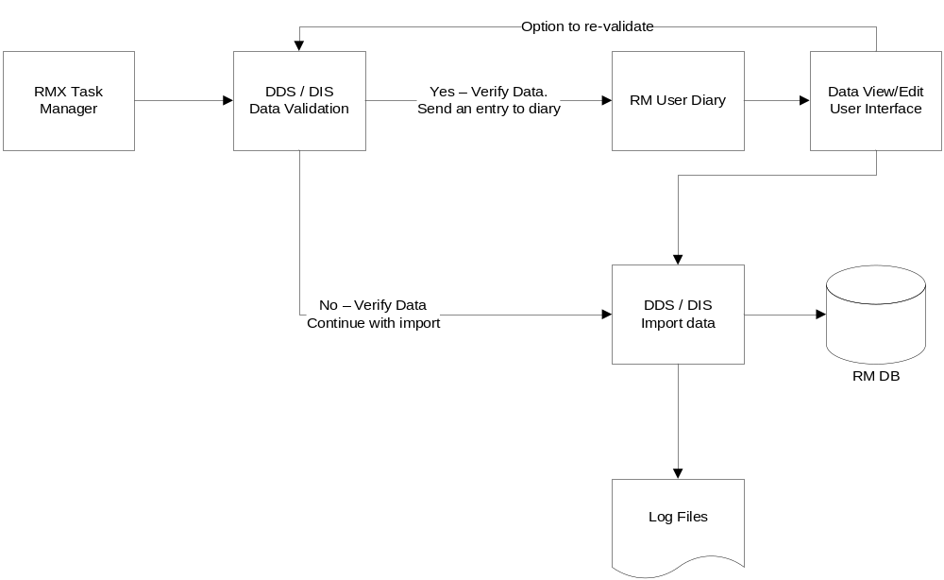

Requirement

Functional Considerations

- Fixed execution order with respect to individual components.
- Validation results recorded on a per-row basis.
- Open-ended supplemental design for fitting to client environment.
- Two-stage process to allow for end-user review of data prior to upload.
- Transactional importing to facilitate rollbacks of incorrect data sets.
- The execution order is consistent, regardless of the select import area.
- Access .mdb database can only run on a 32 bit machine.
- Access mdb can only have 255 columns in a table.
- The Supp Tools will be handled in RISKMSTE X R6 Utilities and is out of the scope of the over all process.

Design Considerations

- The RISKMASTER X application will need access to Data Services.
- Data Services will need to have access to RISKMASTER X temp folders.

Interface Considerations

System Interfaces

No new system interfaces or changes to existing interfaces are needed for this requirement.

Hardware Interfaces

The server that Data Analytics is on will need permission to access and save files to the RISKMASTER X server. Also, the RISKMASTER X server will need be able to access and save file to the Data Analytics server

Software Interfaces

DA DIS, as a supplement to RISKMASTER is dependent on interfaces and libraries present in RISKMASTER. DIS as a SAP Business Objects Data Services template is dependent on SAP Business Objects Data Services job server and its associated repository as the template must be present in the repository to be executable via the job server. The schedulable executable portion of DA DIS, while independent of RMX still has a dependent relationship with a number of core libraries of RISKMASTER.

User Interfaces

The user interface for DA DIS will be placed into the RISKMASTER X Task Manger. By putting DA DIS into the RISKMASTER X Task Manager the user can schedule the DA DIS job. The User interface is also where the user sets the optionset for DA DIS. There will also be a secondary interface to update data which has failed validations will be made available directly to the affected parties.

Performance Considerations

Functional delivery exit criteria do not include performance testing. Performance testing requirements will be defined, where applicable, as part of the RISKMASTER GA release Performance test plan.

Dependencies between Requirements

Based on the Supp Tool functionality mentioned in Section 2.1, this requirement is dependent on the development of the Supp Tool functionality as a RMX Utilities tool.

Approach

DA DIS replaces the existing DIS with a version integrated into RISKMASTER X via the Task Manager. Through careful planning and thoughtful reflection on the organization of a client’s data, DA DIS allows for the creation of a DIS work flow tailored to the client’s own specific business needs. [READ: special criteria and supplemental fields] DA DIS accomplishes this through its five primary components:
- Optionset interface: to allow for user-settings and scheduling
- Schedulable binary: executed by the Task Manager; facilitates logging and error reporting
- Job template (validation): validates source data and moves it to staging
- Post-validation view/edit component: correct any data errors
- Job template (import): import valid data into target RISKMASTER database

These primary components are all wrapped around the existing DA methods. This allows for remote updates, off-schedule validations and imports, concise, descriptive validation and error logs, integrated metrics, and rapid turn-around on custom modifications

Signoff

The signatures below represent approval and signoff of the requirements and approaches as listed above.

________________________________ ___________________
Reviewer(s) Date

________________________________ ___________________
Testing Lead Date

________________________________ ___________________
Program Manager Date

________________________________ ___________________
Development Manager Date

________________________________ ___________________
Hosting Manager Date

Comments: ___________________________________________________________________

References

Requirement Change Log

Date | Change # | Requirement # Revised | Nature of Revision | Initials
08/11/2009 | V1.0 |  | Initial version | MC
08/31/2009 | V2.0 |  | Changes after Review | MC

